East-West Airlines is trying to learn more about its customers. Key issues are their flying patterns, earning and use of frequent flyer rewards, and use of the airline credit card. The task is to identify customer segments via clustering.

Answer:

Dendogram

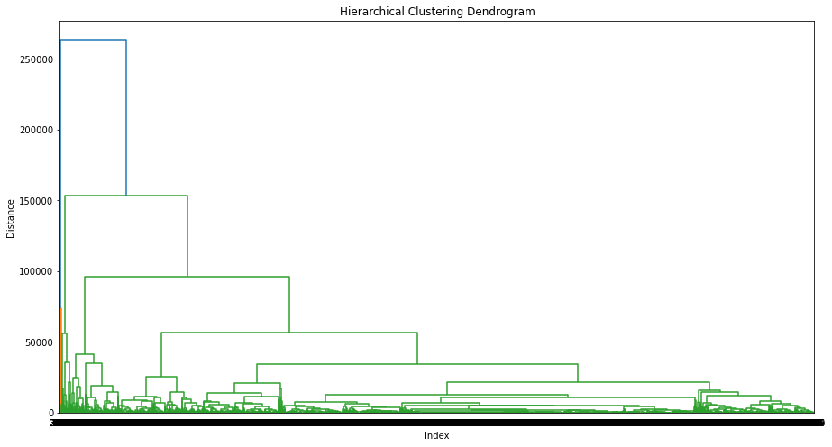

Choosing 4 clusters:

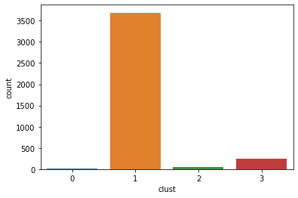

Count:

Cluster customer

1 3689

3 252

2 50

0 8

